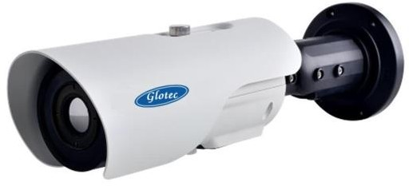

**GL-1IPB**

Thermal Bullet Camera

A thermal camera is an inspection tool that captures infrared energy – radiation emitted from an object – and creates an image. which are fixed bullet network cameras, ideal for security and surveillance applications.

There are multiple lens options available including; 6/8/15/25/35/50/60mm lenses. It is also having temperature measurement functionality with a temperature range of -40°C~150°C. The camera has multiple measurement tools which will allow for a small scale process control monitoring.

**Key Features:-**

* Resolution: 400x300/640x512 IR detector
* Multiple Lens Option: 8mm to 60mm
* ONVIF/API/SDK Compatibility
* Multiple Measurement Tools
* DVE Imaging
* **BIS, CE, ISO, FCC & ROHS** Certified

# Dimensions:-

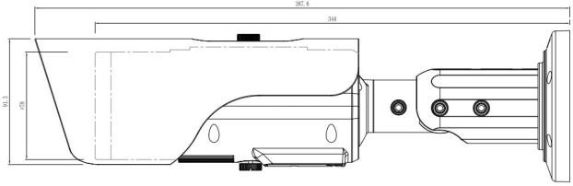

**Specifications:-**

|  |  |  |
| --- | --- | --- |
|  | **GL400 Series** | **GL600 Series** |
| Detector Type | Uncooled IRFPA Microbolometer 17µm | |
| Detector Resolution | 400x300 | 640x512 |
| Thermal Sensitivity (N.E.T.D) | <70mK @F1.0, 300K | |
| Spatial Resolution | 1.09mrad |  |
| Spectral range | 7.5~17μm |  |
| Color Palette | Black-Heat /White-Heat/Rainbow/Iron-Red up to 17 modes | |
| Lens Type | Fixed | |
| Lens Focus | Manual Focus | |
| Features | Electronic Image Stabilization | |
| Video & Audio |  | |
| Compression | H.265, H.264, MUPEG | |
| Frame Rate | Main Stream: D1 @25/30fps | |
| Bit Rate Control | CBR/VBR | |
| Bit Rate | 100Kps~6Mbps | |
| Region of Interest | Off/On (8 Zone, Rectangle) | |
| Digital Zoom | 16x | |
| Mirror/Defog/Motion Detection | Support | |
| Privacy Masking | Off/On (4 Area, Rectangle) | |
| DVE Image Enhance | Support | |
| Audio Compression | G.711, AMR, RAW_PCM (Optionally) | |
| Intelligence |  | |
| Intelligent Functions | Motion Detection, Disk Alarm, I/O alarm, Temperature alarm | |
| IVS | Perimeter, Single Virtual Fences, Double Virtual Fences, Object  left, Object Removed | |
| Detection Mode | Spot, Line, Area Intrusion | |
| Measurement Tools | 3 temperature measurement rule types, 20 rules (20  points/2lines/16regions) | |
| Temperature Alarm | Over temperature alarm, temperature difference alarm | |
| Accuracy | ±2°C/±2% | |
| Response Time | ≤30ms | |
| Environment Working Temperature | -40°C~60°C (-40°f~140°F), Humidity: 10-100% RH  (Condensing) | |
| Measurement Range | -40°C~150°C (-40°f~302°F) | |
| Temperature Display Mode | Temperature Target ≤5°C, Display absolute temperature value, Temperature value (temperature difference DEV= highest value–average) | |
| Network |  | |
| Ethernet | RJ-45 (10/100 Base-T) | |
| Protocols | IPv4/IPv6,HTTP,RTSP/RTP/RTCP,TCP/UDP,DHCP,DNS.PPPOE, SMTP,SIP,802.1x | |
| Interoperability | ONVIF(Profile S,G,T),CGI,SDK | |
| Streaming Type | Unicast | |
| Max. User Access | 10 Users | |
| Edge Storage | Support of Micro SD/Micro SDHC/Micro SDXC card up to 64GB | |
| MTBF Value | 1,00,000 Hrs | |

|  |  |  |
| --- | --- | --- |
|  | **GL400** | **GL600** |
| Memory | 512 MB RAM, 256MB Flash | |
| Web Viewer | ≤IE11, Chrome, Firefox | |
| Web Language | English, Chinese, Polish, Italian, Portuguese, Spanish, Russian,  French,Czech, Hungarian | |
| Interface |  | |
| Ethernet | 1 Ethernet (10/100 Base-T) RJ-45 Connector | |
| Audio Interface | 1ch Audio In, 1ch Audio Out | |
| Alarm | 2ch Alarm In, 2ch Alarm Out | |
| RS485/BNC Output/Reset Button | Support | |
| General |  | |
| Cyber Security | Password Protected, IP Address filtering, HTTPS an encryption, IEEE 802.1X (EAP-TLS) a network access control, Digest Authentications, User access log, centralized certificate management, Brute force delay  Protection, Signed Firmware, Secure boot. | |
| Power Supply | DC12V/POE (IEEE 802, 3af/3at) Type 1 Class 3 | |
| Power Consumption | Max 5W | |
| Operating Temperature | -40°C~60°C (-40°F~140°F) | |
| Storage Conditions | 0~90% RH | |
| Certifications | BIS, CE, ISO, FCC & ROHS | |
| Ingress Protection | N/A | |
| Casing | IP68, NEMA4x, Metal Casing | |
| Dimensions | 110x388mm | |
| Net Weight | 1.9KG | |