

***GL-NVR6216***

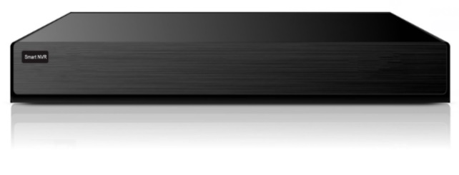



*GL-NVR6216*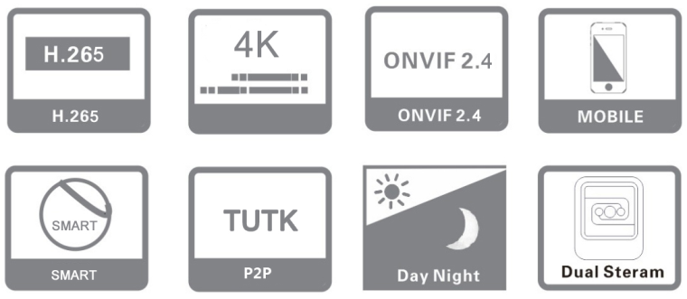

**Key Features:**

* ***Support 16ch 5MP video real-time access, Mini 1U NVR, 1 SATA.***
* ***Support H.265/H.264/MJPEG, embedded Linux operating system.***
* ***Support video playback, remote monitoring and backup.***
* ***Support preview and playback with 12X electronic zoom.***
* ***Standard ONVIF S, G & T, RTSP***
* ***Support DDNS, EMAIL, UPNP, NTP etc.***
* ***Support Web, mobile monitoring, PC client, CMS software.***
* ***Support TUTK P2P***
* ***Support channel grouping, preview cycle.***
* ***Support 16CH 640*480 video synchronous playback and multi-channel synchronous playback backward.***
* ***Support dual password authentication and zero channel function.***
* ***BIS, CE, ISO, FCC & ROHS Compliance.***

**Specification:**

**APPLICATION EXAMPLE :** 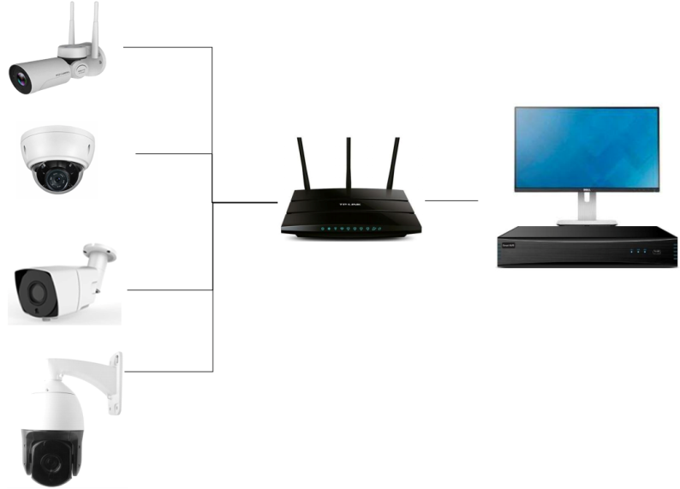

**16 CH & 1SATA 1U 5MP REALTIME H.265 NVR**

|  |  |
| --- | --- |
| ***Specs &***  ***Model No.*** | ***GL-NVR6216*** |
| ***SYSTEM*** | |
| ***Operating System*** | ***Embedded Linux Operating System*** |
| ***VIDEO PARAMETER*** | |
| ***Network Video Input*** | ***16ch 5MP/3MP/1080p/960p/720p*** |
| ***Network Video Output*** | ***VGA/HDMI, 1920×1080@60HZ, 1280×1024@60HZ*** |
| ***Video Bitrate*** | ***16-8000Kbps*** |
| ***Video Input Bandwidth*** | ***60Mbps*** |
| ***Image Preview*** | ***1CH 5MP / 4CH 720P / 6CH Big Picture 5MP; Small Picture:720*567 / 8CH D1/ 16 CH 640*480.*** |
| ***Video Compression*** | ***H.265/H.264/MJPEG*** |
| ***Capture Mode*** | ***Schedule/Manual, JPEG format*** |
| ***AUDIO PARAMETER*** | |
| ***Audio Output*** | ***1CH RCA output*** |
| ***Audio Compression*** | ***G.711A*** |
| ***STORAGE*** | |
| ***HDD Interface*** | ***1 SATA interface*** |
| ***Raid Mode*** | ***N/A*** |
| ***Capacity*** | ***Support Max. 8TB HDD*** |
| ***ALARM*** | |
| ***Motion detection*** | ***Support image set to 396 (22*18) detection areas, multistage sensitivity*** |
| ***NETWORK MANAGEMENT*** | |
| ***Network Protocols*** | ***TCP/IP/ HTTP/ HTTPs/ NTP/ IGMP/ DHCP/ UDP/ SMTP/ RTP/ RTCP/ RTSP/ ARP /DDNS /DNS/ PPPoE/ IPv4/ v6/ QoS/ UPnP/ Bonjour/ IEEE 802.1x/ Multicast/ ICMP/ IGMP/ TLS*** |
| ***Compliance Protocol*** | ***ONVIF Profile S, G & T, RTSP*** |
| ***Remote Application*** | ***WEB(IE, Chrome, Firefox, Safari), iOS, Android Mobile monitor*** |
| ***Others*** | ***Dual password authentication, 0 Channel*** |
| ***Smart Detection*** | ***Object Count, Object left/loss, Area Detection, Line crossing (with Smart IPC)*** |
| ***VIDEO MANAGEMENT*** | |
| ***Record Mode*** | ***Manual/Schedule record, Motion alarm record, Motion alarm Snap, link down record*** |
| ***Record Frame Rate*** | ***1-30fps*** |
| ***Video Query*** | ***Time, Date, Event, Channel, Exact Search (accurate to second)*** |
| ***Record Storage Path*** | ***Local, Network, NAS, IPSAN*** |
| ***Front Smart Detection*** | ***Area Detection, Object Left/Loss, Line Crossing, Object Count*** |
| ***Local Smart Detection*** | ***N/A*** |
| ***PLAYBACK & BACKUP*** | |
| ***Playback Mode*** | ***Regular playback, instant replay, event playback, external file playback*** |
| ***Playback Capability*** | ***1ch (5MP/3MP/1080P) / 4ch(720P)*** |
| ***Playback Operations*** | ***Play, Stop, Forward, Backward, 30s Forward, 30s Backward, Fast play, Slow play, Single frame, Hide/Show the Time Bar, Backup, Screenshot, Full screen selection*** |
| ***Backup Mode*** | ***Removable HDD, USB flash disk, Network backup*** |
| ***EXTERNAL INTERFACE*** | |
| ***Network Interface*** | ***1pcs RJ45 interface (100MEthernet interface )*** |
| ***Audio Interface*** | ***1pcs RCA output*** |
| ***USB Interface*** | ***2PCS 2.0 USB interface (Rear Panel)*** |
| ***RS485 Interface*** | ***N/A*** |
| ***Alarm Interface*** | ***N/A*** |
| ***GENERAL*** | |
| ***Power Supply*** | ***12V 2AMP*** |
| ***Power Consumption*** | ***≤ 10W (Without HDD)*** |
| ***Storage Condition*** | ***-10°C ~ 55°C / 10% - 90%RH*** |
| ***Dimension*** | ***W255 * D218 * H42mm*** |
| ***Weight/pcs*** | ***2 KG*** |

 Home

**\*Product casing and specifications are subject to change without prior notice.**

[**www.glotecinc.com**](http://www.glotecinc.com/)