

***GL-NVR6232***

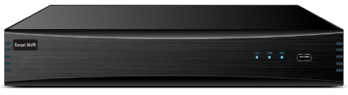



***GL-NVR6232***

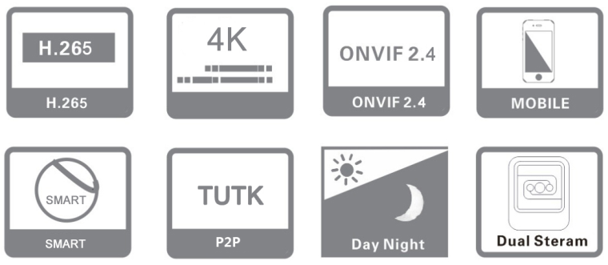

**Key Features:**

* ***32CH full real-time network video access, 1U NVR case***
* ***H.265/H.264 dual-stream decoding, embedded Linux operation system***
* ***Support sync video recording, remote monitoring, backup***
* ***Support dual HDMI Heterologous output, support 2160P HD preview***
* ***Support amplification preview and playback video image***
* ***Standard ONVIF S, G, & T, RTSP***
* ***Support external alarm, dual network port, bidirectional talk, alarm snapshot, email sending functions***
* ***Support DDNS, EMAIL, UPNP, NTP, P2P etc.***
* ***Support WEB, mobile viewer, Client, CMS monitoring***
* ***Support 8ch NVR local intelligent analysis (target counting, left/lost, electronic fence, line crossing detection)***
* ***support IPC intelligent functions (target counting, items left/lost, electronic fence, crossing detection, retrograde detection, departure detection)***
* ***Support grouping disk quota, and disk inventory two storage pattern, distribute different video storage capacity or cycle according to different channels***
* ***Support IPC centralized management, including IPC parameters configuration, import and export information, information real time acquisition, etc.***
* ***Dual Gigabit network card, supporting dual network IP settings and other applications***
* ***Support channel grouping, preview round touring***
* ***Support network detection (network flow monitoring, network Wireshark, network clear) functioned.***
* ***Support max 16CH 1080P sync playback and multi-channel sync play backward***
* ***Support instant playback***
* ***The new UI interface, support a key to open the video recording***
* ***Support dual password authentication, N+1 hot backup, IP filter***
* ***BIS, CE, FCC, ISO & ROHS Compliance***

**Specification:**

 Home

**32CH & 4SATA 1U 4K REALTIME H.265 NVR**

|  |  |  |
| --- | --- | --- |
| ***Specs & Model No.*** | | ***GL-NVR6232*** |
| ***VIDEO*** | | |
| ***Network video input*** | ***32CH*** | |
| ***Network access bandwidth*** | ***150Mbps*** | |
| ***Video compression*** | ***H.265/H.265+/H.264/H.264+*** | |
| ***Video output*** | ***VGA output（1920×1080@60HZ,1280×1024@60HZ）*** | |
| ***HD HDMI output（3840×2160@30HZ,1920×1080@60HZ,1280× 1024@60HZ）*** | |
| ***Display mode*** | ***Synchronous output, heterosource output*** | |
| ***System mode*** | ***16 digits +16 preview +8 playback +8 channel intelligence*** | |
| ***Video bit rate*** | ***16-16000Kbps*** | |
| ***Video resolution*** | ***4K/5MP/4MP/3MP/1080P/960P/720P/D1/VGA/4CIF/DCIF/2CIF/CIF/QCIF*** | |
| ***Image display*** | ***1/4/6/8/9/16/25/36 image display*** | |
| ***Snapshot mode*** | ***Support timing snapshot, manual snapshot, JPEG format*** | |
| ***Motion detection*** | ***Support 396(22*18) surveyed area can be set in every screen and multi-level sensitivity adjustable*** | |
| ***Privacy mask*** | ***Support 4 zones*** | |
| ***intelligent detection*** | ***Support NVR local intelligent analysis (target counting, left/lost, electronic fence, line crossing detection)/ support IPC intelligent functions (target counting, items left/lost, electronic fence, crossing Line detection,Intrusion Detection, departure detection)*** | |
| ***AUDIO*** | | |
| ***Audio compression*** | ***G.711ulaw/G.711alaw/G.722/G.726*** | |
| ***Audio input*** | ***1 CH RCA port (IPC complex audio input)*** | |
| ***Audio output*** | ***1 CH RCA port*** | |
| ***Bidirectional talk input*** | ***Bidirectional talk, RCA port*** | |
| ***VIDEO RECORDING AND PLAYBACK*** | | |
| ***Video frame rate*** | ***1-30fps*** | |
| ***Recording Resolution*** | ***8 MP/6 MP/5 MP/4 MP/3 MP/ 1080p /UXGA /720p/VGA / 4CIF / DCIF/ 2CIF /CIF / QCIF*** | |
| ***Playback ability*** | ***Support 4CH 4K/ 5MP/ 4MP, 9 CH 3MP, 16 CH 1080P record sync playback*** | |
| ***Playback mode*** | ***Multi-channel real-time recording, Instant playback, local record, Playback snapshot, external file playback*** | |
| ***Record search*** | ***Time, calendar, channel search, event search, (ANR, regular video, motion detection video, alarm video, intelligent detection video)*** | |
| ***Video playback*** | ***Start time, play/pause, stop, forward, backward, single frame, forward 30 seconds, backward 30 seconds, fast play(1-256X), slow play(1-1/32X), 1/4/9/16 split screen, previous page, next page, backup, capture, show hidden progress bar, full screen, roller amplification time bar precise playback*** | |
| ***STORAGE AND BACKUP*** | | |
| ***Storage interface*** | ***4个SATA*** | |
| ***HDD capacity*** | ***Single max.10TB*** | |
| ***Disk grouping*** | ***According video channels to set HDD quantity*** | |
| ***Disk quota*** | ***According video channels to set HDD storage capacity*** | |
| ***Backup location*** | ***Local, network, NAS, IPSAN*** | |
| ***Backup method*** | ***USB mobile hard disk, U disk, network backup*** | |
| ***FUNCTION*** | | |
| ***Network protocol*** | ***TCP/IP, HTTP, HTTPS,*** ***DHCP, IPv4, IPv6, DNS, DDNS, NTP, RTSP, SADP, SMTP, SNMP, NFS, iSCSI, ISUP,***  ***UPnP™*** | |
| ***Interface protocol*** | ***ONVIF Profile S, G & T, RTSP*** | |
| ***Protocol port*** | ***ONVIF/RTSP/HTTP/HTTPS/RTMP port customized*** | |
| ***Mobile surveillance*** | ***Support Apple, Android*** | |
| ***Internet explorer*** | ***Support IE, Chrome, Firefox, Safari*** | |
| ***Display function*** | ***Channel shortcuts: modify the channel, 3D positioning, display AI intelligent rules and results, capture, voice intercom, channel audio, manual recording, instant playback, video parameters*** | |
| ***Desktop display: audio input, volume, alarm information (deployment/removal), P2P cloud service, network information, Output adjustment, system information, device list (showing whether IPC is***  ***online or not, recording type), organizational structure (custom channel classification for quick preview), channel round tour, 1/4/6/8/9/16/25/36 split screen, open round tour, open linkage preview, file backup full screen hide OSD、PTZ control,*** | |
| ***IPC timing*** | ***Manual/auto/timing/reconnect timing to IPC timing*** | |
| ***Alarm linkage*** | ***Send email, audible warning buzzer), alarm on monitor, upload to center, record, snapshot, preview, PTZ linkage*** | |
| ***Network detection*** | ***Flow monitoring, network Wireshark, network test*** | |
| ***User management*** | ***User add, delete, modify, permission management, FACE eye Scan the QR code to retrieve the password*** | |
| ***Auxiliary users(secondary password protection)*** | |
| ***Manage IPC*** | ***Modify IPC parameters*** | |
| ***EXT INTERFACE*** | | |
| ***Network interface*** | ***2 *RJ45 10/100/1000 Mbps self-adaptive Ethernet port*** | |
| ***Alarm input*** | ***4CH*** | |
| ***Alarm output*** | ***1CH*** | |
| ***RS-485*** | ***1CH*** | |
| ***USB backup Operator interface*** | ***16-bit true color graphic menu operation, Front panel: 1*USB2.0, Rear panel: 1*USB2.0*** | |
| ***Physical Layer of Ethernet*** | ***10/100/l000 Base TX*** | |
| ***GENERAL*** | | |
| ***Power supply*** | ***DC12V/3.33A*** | |
| ***Power consumption*** | ***≤10W（Without HDD）*** | |
| ***Operation temperature*** | ***-10°C ~ 55°C/10﹪-90﹪*** | |
| ***Dimension(mm)*** | ***360(L)x242.2(W)x48(H)mm*** | |
| ***Weight/PCS(without HDD)*** | ***2KG（Without HDD）*** | |

**\*Product casing and specifications are subject to change without prior notice.**

[**www.glotecinc.com**](http://www.glotecinc.com)