***GL-NVR8964***

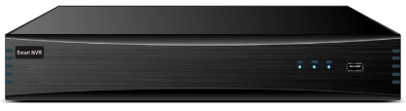



***GL-NVR8964***

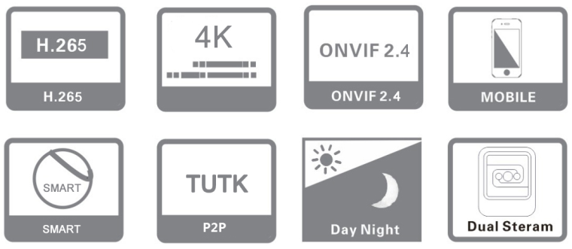

**Key Features:**

* ***64CH full real-time network video access, 2U NVR case***
* ***H.265, H.264 dual-stream decoding, embedded Linux operation system***
* ***Support sync video recording, remote monitoring, backup***
* ***Support dual HDMI Heterologous output, support 2160P HD preview***
* ***Support amplification preview and playback video image***
* ***Standard ONVIF, RTSP***
* ***Support external alarm, dual network port, bi-direction talk, alarm snapshot, email sending functions***
* ***Support DDNS, EMAIL, UPNP, NTP, P2P etc.***
* ***Support WEB, mobile viewer, Client, CMS monitoring***
* ***Support 8ch NVR local intelligent analysis (target counting, left/lost, electronic fence, line crossing detection)***
* ***Support IPC intelligent functions (target counting, items left/lost, face recognition, crossing detection, retrograde detection, departure detection)***
* ***Support grouping disk quota, and disk inventory two storage pattern, distribute different video storage capacity or cycle according to different channels***
* ***Support IPC centralized management, including IPC parameters configuration, import and export information, information real time acquisition, etc.***
* ***Dual Gigabit network card, supporting dual network IP settings and other applications***
* ***Support RAID0, RAID1, RAID5, RAID6 and RAID10, overall hot-backup***
* ***Support channel grouping, preview round touring***
* ***Support network detection network flow monitoring, network Wireshark, network clear function, etc.***
* ***Support max 16CH 1080P sync playback and multi-channel sync play backward***
* ***Support instant playback***
* ***The new UI interface, support a key to open the video recording***
* ***Support dual password authentication、 N+1 hot backup, IP filter,***
* ***BIS, CE, FCC, ISO & ROHS Compliance***

 **Specification:**

 Home

**64 CH & 9SATA 2U 12MP (4K) REALTIME H.265 NVR**

|  |  |  |
| --- | --- | --- |
| ***Specs & Model No.*** | | ***GL-NVR8964*** |
| ***VIDEO*** | | |
| ***Network video input*** | ***64CH*** | |
| ***Network bandwidth*** | ***512Mbps*** | |
| ***Video compression*** | ***H.265/H.264/MJPEG*** | |
| ***Video output*** | ***2CH VGA output（1920×1080@60HZ,1280×1024@60HZ）*** | |
| ***HD HDMI output（3840×2160@30HZ,1920×1080@60HZ,1280× 1024@60HZ）*** | |
| ***HDMI 1 output（1920×1080@60HZ）*** | |
| ***Display mode*** | ***Synchronous output, heterosource output*** | |
| ***System mode*** | ***64 digits +36 preview +16 playback +8 channel intelligence***  ***64 digits +64 preview +16 playback*** | |
| ***Video bit rate*** | ***16-16000Kbps*** | |
| ***Video resolution*** | ***4K/5MP/4MP/3MP/1080P/960P/720P/D1/VGA/4CIF/DCIF/2CIF/CIF/QCIF*** | |
| ***Image display*** | ***1/4/6/8/9/16/25/36/64 image display*** | |
| ***Motion detection*** | ***Support 396(22*18) surveyed area can be set in every screen and multi-level sensitivity adjustable*** | |
| ***Privacy mask*** | ***Support 4 zones*** | |
| ***intelligent detection*** | ***Support 8ch NVR local intelligent analysis (target counting, left/lost, Face detection, face recognition) /video metadata (human, motor vehicles,), ANPR, Heat map, Vehicle Density, Electric fence, line Crossing, Motion Detection, Leave Position Detection*** | |
| ***AUDIO*** | | |
| ***Audio compression*** | ***G.711u, G.711a, G726, PCM*** | |
| ***Audio input*** | ***1 CH RCA port (IPC complex audio input)*** | |
| ***Audio output*** | ***2 CH RCA port*** | |
| ***Bidirectional talk input*** | ***Bidirectional talk, RCA port*** | |
| ***VIDEO RECORDING AND PLAYBACK*** | | |
| ***Video frame rate*** | ***1-30fps*** | |
| ***Record mode*** | ***manual/Timing record and alarm record/Timing record/alarm record/Stop record*** | |
| ***Playback ability*** | ***Support 4CH 4K/ 5MP/ 4MP, 9 CH 3MP, 16 CH 1080P record sync playback*** | |
| ***Playback mode*** | ***Instant playback, local record, Playback snapshot, external file playback, smart playback (face and motion detection), timing and alarm,*** ***Manual*** | |
| ***Record search*** | ***Time, calendar, channel search, event search, (ANR, regular video, motion detection video, alarm video, intelligent detection video)*** | |
| ***Video playback*** | ***Start time, play/pause, stop, forward, backward, single frame, forward 30 seconds, backward 30 seconds, fast play(1-256X), slow play(1-1/32X), 1/4/9/16 split screen, previous page, next page, backup, capture, show hidden progress bar, full screen, roller amplification time bar precise playback*** | |
| ***STORAGE AND BACKUP*** | | |
| ***Storage interface*** | ***8个SATA、1 个E-SATA*** | |
| ***HDD capacity*** | ***Single max.20TB*** | |
| ***RAM*** | ***16 GB DDR RAM Upgradable to 64 GB*** | |
| ***Disk grouping*** | ***According video channels to set HDD quantity*** | |
| ***Disk quota*** | ***According video channels to set HDD storage capacity*** | |
| ***Backup location*** | ***Local, network, NAS, IPSAN*** | |
| ***Array type*** | ***Raid0、Raid1、Raid5、Raid6、Raid10、*** | |
| ***Storage Capacity & OS HDD*** | ***Supports up to 160TB or higher & 256GB SSD*** | |
| ***Backup method*** | ***USB mobile hard disk, U disk, network backup*** | |
| ***FUNCTION*** | | |
| ***Network protocol*** | ***TCP/IP,HTTP,HTTPS,DDNS,SMTP(SSL),DHCP,PPPoE,UPnP,NTP,P2P,IPv4,IPv6*** | |
| ***Interface protocol*** | ***ONVIF Profile S, G & T, RTSP*** | |
| ***Protocol port*** | ***ONVIF/RTSP/HTTP/HTTPS/RTMP port customized*** | |
| ***Mobile surveillance*** | ***Support Apple, Android*** | |
| ***Internet explorer*** | ***Support IE, Chrome, Firefox, Safari*** | |
| ***Display function*** | ***Channel shortcuts: modify the channel, 3D positioning, display AI intelligent rules and results, capture, voice intercom, channel audio, manual recording, instant playback, video parameters*** | |
| ***Desktop display: audio input, volume, alarm information (deployment/removal), P2P cloud service, network information, Output adjustment, system information, device list (showing whether IPC is***  ***online or not, recording type), organizational structure (custom channel classification for quick preview), channel round tour, 1/4/6/8/9/16/25/36/64 split screen, open round tour, open linkage preview, file backup full screen hide OSD、PTZ control,*** | |
| ***IPC timing*** | ***Manual/auto/timing/reconnect timing to IPC timing*** | |
| ***Alarm linkage*** | ***Send email, audible warning buzzer), alarm on monitor, upload to center, record, snapshot, preview, PTZ linkage*** | |
| ***User management*** | ***User add, delete, modify, permission management, FACE eye Scan the QR code to retrieve the password, Auxiliary users(secondary password protection)*** | |
| ***Manage IPC*** | ***Modify IPC parameters*** | |
| ***Failover feature*** | ***NVR shall support N+1 system level protection and backup.*** | |
| ***EXT INTERFACE*** | | |
| ***Network interface*** | ***2 *RJ45 10M/100M /1000M adaptive Ethernet port*** | |
| ***Alarm input*** | ***16CH*** | |
| ***Alarm output*** | ***8CH*** | |
| ***RS-485*** | ***2CH*** | |
| ***USB Port*** | ***Front panel: 2*USB2.0，Rear panel: 2*USB3.0, 1 eSATA Port, 1 RS232*** | |
| ***User Interface*** | ***Web, Local GUI*** | |
| ***General Alarm*** | ***Motion detection, privacy masking*** | |
| ***Anomaly Alarm*** | ***Anomaly Alarm, login lock, abnormal behavior of fan, storage error, disk full, IP conflict, MAC conflict,***  ***cybersecurity exception*** | |
| ***GENERAL*** | | |
| ***Power supply*** | ***AC100～240V，50Hz～60Hz（Power plug specification optional）*** | |
| ***Power consumption*** | ***≤35W（Without HDD）*** | |
| ***Operation temperature*** | ***-10°C ~ 55°C/10% -90%*** | |
| ***Dimension(mm)*** | ***440(L)x432(W)x90(H)mm*** | |

**\*Product casing and specifications are subject to change without prior notice.**

[**www.glotecinc.com**](http://www.glotecinc.com/)